DETECTING RENAL DISEASE USING METACLASSIFIERS

Srithar S
C.S Student, Department of Computer science and Engineering,
Koneru Lakshmaiah Education Foundation,
Vaddeswaram, Andhra Pradesh, India
sss.srithar@gmail.com

Kanaga Priya P
Department of Computer science and Engineering,
KPR Institute of Engineering and Technology,
Coimbatore

Srithar S
Department of Computer science and Engineering,
Koneru Lakshmaiah Education Foundation,
Vaddeswaram, Andhra Pradesh, India
sss.srithar@gmail.com

Dr. S. Athinarayanan
Department of Computer science and Engineering, Annamacharya Institute of Technology and Sciences, Tirupati - 517520
Vetrimani E
Department of Computer science and Engineering,
Presidency University,
Bangalore, India

G.Ramesh Kalyan
Department of Computer science and Engineering, SNS College of Technology , Coimbatore

Abstract—Because of the elevated risk of illness and fatality ,chronic kidney disease is regarded as a serious health issue. Renal disease is also called as Kidney disease.Kidney infections are particularly challenging to diagnose since they progress slowly and continuously. For the same reason, a lot of patients wait until the very end stage to diagnose their condition. It’s critical to have trustworthy methods for early stage of Renal Disease assessment. Machine learning approaches are crucial for illness diagnosis and early-stage diagnosis. This project’s primary goal is to evaluate the Renal Disease risk stage. This model is created utilizing classification methods that are used as meta classifiers to define the danger stage. The technique is broken up into different stages to complete the goal. The conventional data is pre-processed in the first module. The methods used to calculate pre-processing are label encoding and standard scalar. Extra tree classifiers are used as meta classifiers to process the data along with base classifiers like KNN and Random Forest. As a result, the kidney infection risk stage is known.
Keywords—Cyber-physical system, Handover, Autonomous vehicles, Packet transmission, Medium access control.

Introduction
Your kidneys are damaged and aren't properly filtering your blood if you have renal disease. The main function of the kidneys is to remove surplus water and waste from the blood in order to generate urine, therefore if someone has renal disease, it signifies that wastes have accumulated in the body. Because the harm was done gradually over a lengthy period of time, this illness is chronic. It is nice to say that it is a widespread ailment renal disease may cause some health issues. The main objective of this project is to predict and diagnose chronic renal disease using the Extra Tree classifier and the Random Forest algorithm as meta classifiers. We will break the process down into separate modules in order to complete the task. The first module contains the conventionally pre-processed. The following module uses an extra tree classifier technique to calculate. The number of renal patients is rising quickly today, and it is crucial to identify the disease early and take the appropriate steps to prevent it from spreading. We propose using some of the traits to predict the risk of renal disease. In order to estimate the risk of renal disease, we must first gather sample data from a patient who has kidney infection. An essential part in predicting renal disease is machine learning. The primary goal is to forecast kidney disease using pertinent data from a sizable database. Early renal disease diagnosis is crucial for saving the patient's life and preserving our ability to lead regular lives. Machine learning is becoming increasingly significant since it facilitates the analysis and summarization of data from various perspectives. There are many causes for renal disease like diabetes, high blood pressure, heart disease. Along with these critical diseases, renal disease also depends on age and gender . According to the recommendations for diagnosing and staging, renal disease is a condition in which a person has either substantial kidney damage or a Glomerular Filtration Rate (GFR) that has been below 60 ml/min/1.73 m2 for more than three months. It was also recommended to utilise Glomerular Filteration Rate as the best measure of renal function to distinguish between the various stages of chronic renal disease , with each stage describing a more severe decline in Glomerular Filterate Rate and the final stage defining kidney failure with a GFR 15 ml/min/1.73 m2 [12]. It can be challenging to diagnose kidney illness in its early stages since it frequently has few noticeable symptoms. Early detection is thought to be a key component in the treatment and management of chronic renal disease. The goal of the proposed system was to estimate the risk stage of Chronic Renal Disease using an efficient model and to outperform existing methods in terms of accuracy. Machine learning algorithms perform significantly better than other models. By using meta-classifiers, the suggested method predicts the risk of Chronic Renal Disease in its early phases. This suggested technique aids in the early detection of renal disease in individuals, hence saving lives. Therefore, in future research, scientists can develop a model that predicts the probability of Chronic Renal Disease using fewer features and also specifies the measures infected patients must take.

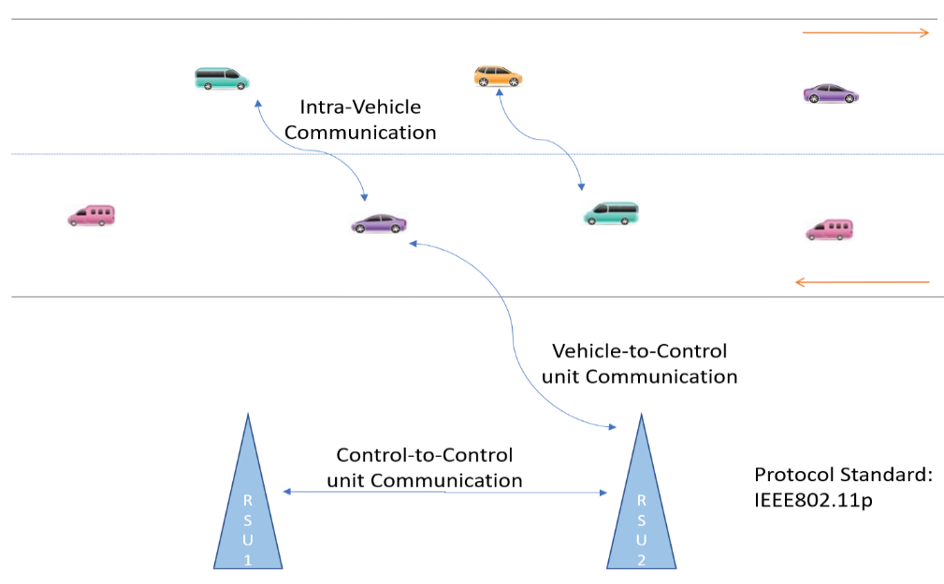
- Vehicular multi-hop ad-hoc Communication
The distributed autonomous vehicle can collect the information by the deep observation of the surroundings, whereas inter-vehicle communication is a prominent part of emergency message distribution. The current Intelligent Transportation System (S-ITS) adopt the communication standards such as IEsEE802.11p, DSRC, and IEEE609.4 (WAVE) are commonly accepted in highway and urban environment. The defined standard is good to work on intra-vehicle, inter-vehicle, and inter RSUs [5][6]. Some key indicators slightly differ the ad-hoc autonomous vehicular networks with ad-hoc mobile networks. The vehicular node could not suffer from the energy, because the node is equipped with power, whereas the mobile ad-hoc node highly suffers from energy loss [10][11]. The rapid speed of vehicular nodes will collapse the reliability of the network topology. The multi-hop vehicular communication scenario is represented in Fig. 1.

Introduction

RELATED WORK
Vijaya Padma G et al. [17] investigated the traffic interaction control by the great circle algorithm. Each vehicle cooperatively distributes multicast messages to know the current status of the partner vehicle to avoid the clash. To avoid the unwanted flooding of broadcasting the collision avoidance scheme is introduces.
Shaik, S et al. [9] investigated the enhanced CLCR for appropriate reliable node selection by neighbor set ratio. The relay selection is depending on the stability of the link among the peers in the network.
S. Shafi et al. [8] investigated CLARR routing that selects the most optimal link by taking the least possible hops to reach the destination and adding the link lifetime into the request packet.
B. M. Reddy et al. [2] investigated the effective routing vehicle to the gateway and vice versa. The gateway will broadcast the tiny message to all the surrounding nodes to know the partner peer vehicle. Those who belong to a gateway are identified through the token.
Srithar S, Saravanakumar NM [15] discussed and route cause of highway accidents in a road environment. As per the WHO report the unpredictable overtaking and over speeding are the primary reason for 70 percent of the accidents. The comfort zone boundary prediction COSA method is used to predict the safe and unsafe zone.
Basha, S et al. [3] investigated the cost-effective forwarder selection by considering the mobility, density, and distance. The quality of the relay is considered before the packet transmission.
R. Sadakale, et al. [7] investigated the reactive protocol performance evaluation for transmission delivery success rate and communication delay. The analysis taken the traffic parameter such as TCP and UDP into the consideration.
K. Karuppasamy and S. Srithar [4] investigated the various routing protocols and their performance analysis for the mobile ad-hoc environment. The analysis shows that the reactive version of the protocols such as DSR and AODV provide an optimal result in terms of packet delivery success ratio.
Srithar, S., Saravanakumar, N.M. [14] investigated the movement prediction by considering the heterogeneous parameters like speed, range, and position. The reliability of the path is ensured by the right selection of intermediate relay through link and path age.
S.NO | STAGE 1 | STAGE2 | STAGE 3A | STAGE 3B | STAGE 4 | STAGE 5
eGFR | 90 or greater | Between 60 and 89 | Between 45 and 59 | Between 30 and 44 | Between 15 and 29 | Lessthan 15
Level Of Kidney Damage | Mild kidney damage | Mild kidney damage | Mild to moderated kidney damage | Mild to moderate kidney damage | Moderate to severe kidney damage | End stage.kidneys are close to failure.need dialysis or kidney transplantation

PROBLEM FORMULATION
The usage of IEEE802.11p is not always preferred specifically in the highway environment. Because the protocol is heavily relying on the navigation device coordinate values. The device connectivity in remote areas is quite less compared with the urban environment. In such a scenario, the protocol IEEE802.11ax has to be an alternative over IEEE802.11p [12][13]. The protocol also can handle a large number of IoT devices in a network. The average data rate of AX is 1.3gbps which can operate at 2.4 or 5 GHz of frequency bands. The protocol standard is also termed M-UIO (Multi-User/Input/Output) that follows frequency division multiple access. The new standard is used by roadside control units for optimal connectivity with the slave nodes. The configuration of the protocol can be of IEEE 802.11n standard which utilizes the same frequency of IEEE802.11ax with an outdoor coverage range up to 250 meters. The hybrid handover scheme will improve the power of reliable connections in the highway environment. The signal strength indicator is commonly used in traditional systems during the ad-hoc device handover. The handover probability is highly dependent on the disconnection rate with the current network-connected device. The time taken to hand over from one network to another network without disturbing the packet transmission will give an optimal impact. The proposed solution will effectively carry over the current session to the relay agent with proper authentication.

AUTONOMOUS CYBER-PHYSICAL SYSTEM FUNDAMENTALS
The smart vehicle should have some basic units such as GNSS, IMU/ultrasonic sensor, actuator, LIDAR, and RADAR, etc. In addition to that, the communication among the wireless components is done through the IEEE802.11a standard. The standard uses a 5GHZ frequency band which can transfer up to 54mbps. The autonomous vehicle uses the technologies such as artificial intelligence, radar, and lidar. The sensor technology is used to detect the target object whereas the AI provides the intelligence to make self-decisions. The sensor actuators are classified as,

Exteroceptive

RADAR: It is a type of sensor device which can transmit a radio signal and measure the distance between the objects with the reflected signal. The device can work even with low visibility. The radar uses electromagnetic microwaves which can travel 300000-kilo meters per second. The radio waves are between 30Hz and 300GHz, whereas the microwave wavelength is smaller than 1GHz.Since the microwaves can pass through darkness or sunshine. The radio waves can transmit through the mist, fog, rain, and smoke. The device can detect the range, field of view, position, and speed accuracy.

LIDAR: A light beam is transmitted and looks for the reflection. Time taken for light beam travel and reflection is to calculate the gap between the current and intermediate object. The beams transmitted such as 8,16,32 and 64 points per second. It can work under any environmental conditions. It can take both 2D and 3D input for processing. The 3D LiDAR will spread multiple laser beams vertically to get the 3-dimensional axes, whereas the 2D LiDAR spread a single beam horizontally to get the 2-dimensional axes to attain the target object.

Cameras: The smart vehicle contains high-quality image capturing cameras for image processing. The resolution, field of angle view, and coverage range of the camera should be good enough. The stereo cameras are used for depth image data estimation.

Ultrasonic sensor: The sensor follows the concept of sound navigation and ranging. The sensor produces sound waves and transmits them over the air and looks for the reflection. The reflection is captured by the receiver and measures the distance.

Proprioceptive

GNSS: The GNSS provides the general form of describing the satellite services like navigation, positioning, and timing. Every country owns or utilizes public GNSS systems for weather forecasting, military application. The most utilized GPS service is now publicly available for the globe which is offered by the USA. The GNSS device will show the latitude and longitude of the device's location. This cyber-physical device contains three layers such as space, control, and user segment.

IMU sensor: The sensor can measure the speed, direction, acceleration, angular rate, force, etc. The angular rotation of the wheel is also estimated through the IMU sensor.

Controller: The controller unit contains an optimized CPU core that can perform some anonymous tasks. The unit collects the sense the information and group it according to their characteristics. Every controller trigger whenever the unit reaches the fixed threshold.

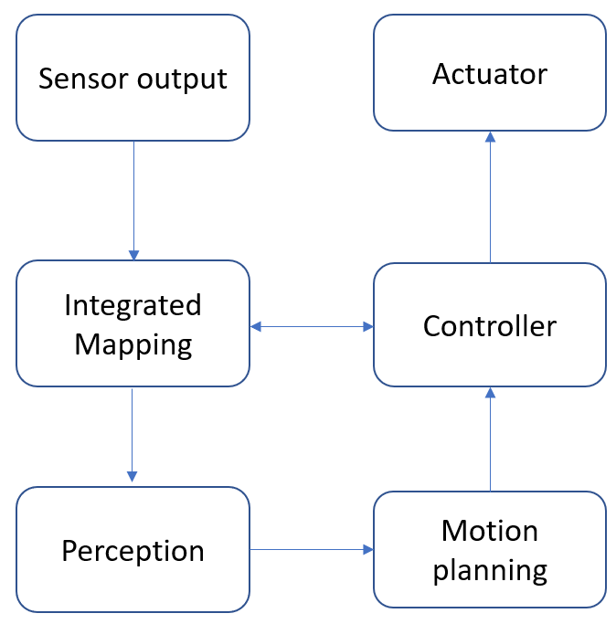

- Autonomous vehicle behaviour
The technology Internet of Everything (IoE) came into the picture to have proper communication among the around the peer vehicle. The implementation of IoE in an autonomous vehicular environment is a challenging task. The frequent topology changes and heterogeneous vehicle behavior will seriously disturb the packet transmission rate. To have proper connectivity among the partner nodes the cyber-physical devices should be connected over the interconnected network. The improper cooperativeness among the cyber system also issues trouble to the communication channel. The network breakage will happen during the hub jump. During hub jump, the current network must hand over the connection to the available interconnected network through soft or hard handover. The process flow of sensing to actuation is shown in Fig. 2. The commonly used sensor devices namely lidar, radar, and ultrasonic sensor. The radar sensor uses radio waves to detect the target position with the current vehicle location. The application of radar such as blind-spot detection, lane observation, and parking. The lidar sensor uses laser waves which can detect 360-degree three-dimensional image capture to detect the objects. Nowadays uber, Toyota and google car are using this sensing technology. Finally, the ultrasonic sensor is used to detect close objects from 10 to 15 meters.

MULTI-HOP BRIDGE RESERVATION MEDIUM ACCESS CONTROL (MBR-MAC)

The mobile devices will check the signal strength with the current RSU at regular intervals. The signal strength should be greater than the defined threshold limit. Whenever the signal strength is lesser than the defined limit, the request message is transmitted to the RSU and looking for acknowledgment. Now the RSU will transmit a current channel availability request to the nearby RSU. If the channel is available, the RSU will forward a channel availability response message to the requested RSU. The current RSU will send an implicit acknowledgment to the handover requested vehicle. The requested vehicle will get the token and connect to the new RSU. The handover process will not reduce the performance of the data transmission in any cause. The process of MBR-MAC handover between different network are said to be inter-cell handover, whereas the handover takes place within the cell are named as intra-cell handover. The process of MBR-MAC handover is represented in Fig. 3.
All the vehicles will send a continuous request message to the RSUs whenever the RSSI value is less than the threshold. The RSUs will check the availability of the channel and issue and acknowledge the message to the vehicle. The vehicle will come to know that the reachability of the RSUs is sending the periodic test bounds.
S₁=(Test reply received time-Test message sent time)*1 (1)

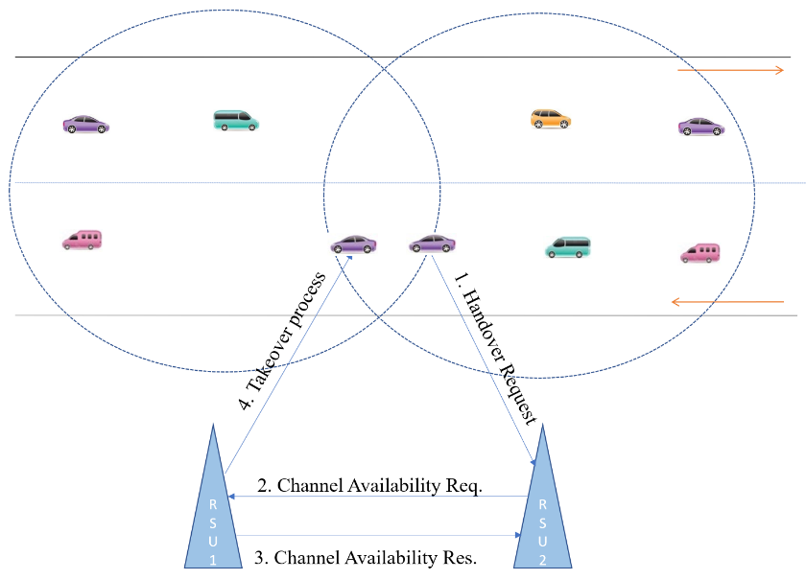
- Handover Request-Response Success model

Handover Multiplexing Techniques
The proposed system utilizes the time and code division reservation multiple access techniques during the channel allocation. Because the takeover process is only depending on the availability of the bandwidth among the number of child vehicles. The vehicle will sense the medium and checks for the available slots for collision-free communication. Whenever the medium is free the vehicle can directly communicate with the control unit. If not, the mobile vehicle follows the non-persistent or p-persistent sensing technique. The channel access collision is explicitly handled by transmitting periodic RTS and CTS messages [16]. This technique greatly reduces the hidden and exposed terminal problems. Especially in self-organized networks, autonomous perception without considering neighbor node activities may mislead the network into disconnection. In MANETs the mobility of the vehicle is too low and there we have time to experiment with the connectivity. But in vehicular networks, the mobility of the network-connected vehicle is quick. The perception and handover process needs to be quickly processed through the cooperative control scheme. The reservation scheme will try to allocate the channel well in advance for the handover requested vehicle.
The proposed system utilizes the soft handover technique to avoid the rupture link. The cluster formation contains some intersection points to initiate the handover process. Whenever the vehicle reaches the intersection point then the handover request is transmitted to the nearest RSCU. The accepter RSCU test whether there is any free channel to handle the requester. If the slot is available, then the acknowledgment message is transmitted to the requester. This process is repeated till gets the free slot acknowledgment.

Channel Reservation
The RSU is the whole responsibility to ensure the stability connectivity with the peer vehicle. Also, to assign the right channel for all the requested vehicles to have communication. Whenever multiple vehicles looking for the channel, the control unit should assign the channel well in advance for communication. The movement prediction is the key parameter during the channel allocation. The slot reservation during the handover is represented in Fig. 4.

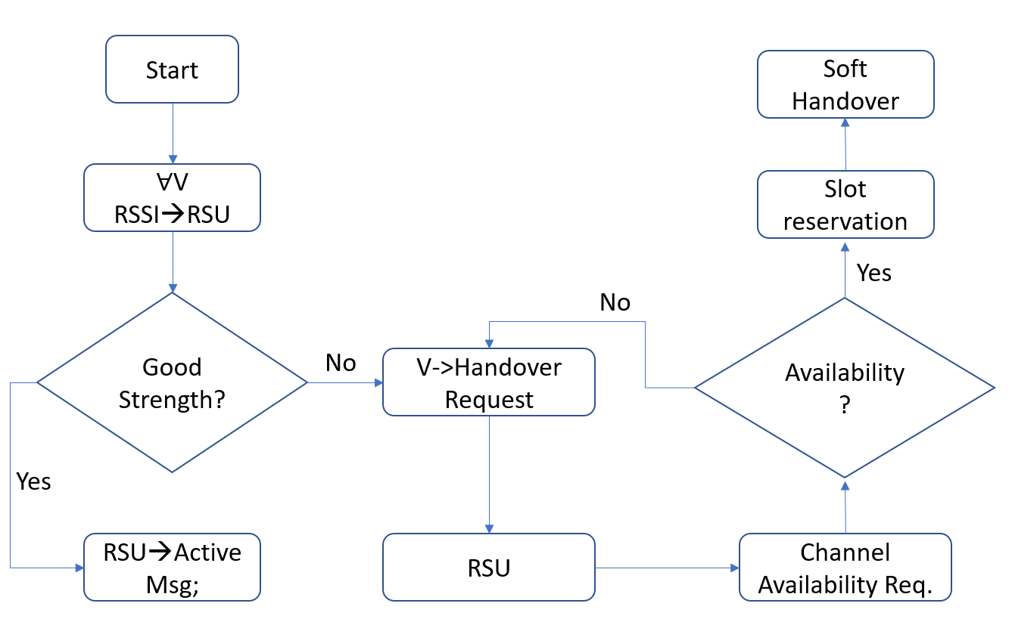
- Slot reservation Process Flow
The proposed methodology may suffer from spoofing and sensor jamming attacks. The attack spoofing is eliminated by position verification methodology whereas the sensor jamming attack is removed backup filtering approach. The position verification is done by the cluster head and RSCU through its running data. The backup filtering approach will look at the data continuity and inform to control unit in case of data absence.

RESULTS AND EXPERIMENTATION
The bridge reservation scheme is practically simulated in Network Simulator-2. The NS2 simulator is specially designed to simulate the working scenario of the environment virtually for WSN, vehicular network, and mobile Ad-hoc network. The tool utilizes the front-end and backend languages such as OTCL and C++. The tool supports the network protocols such as UDP and TCP with different traffic like Telnet, CBR, VBR, FTP, etc. The tool also has built-in routing protocols such as AODV, DSDV, DSR, etc. The simulation utilizes the IEEE802.11p for communication among the vehicle and the RSUs. The range and speed of the vehicle are assigned in a heterogeneous fashion. The entire simulation takes 1kb of binary data packet for dissemination. The proposed approach compared the performance for packet transmission delivery rate, handover delay with some existing approaches. The simulation parameters are tabulated in Table 1. The reservation protocol algorithm is compared with the SOMMAC [5] and PMIP-MIVH [7].
- SIMULATION PARAMETERS
Parameters | Value
Simulator tool | NS2.34
Area | 2000*2000
MAC type | IEEE 802.11p
vehicle speed | 50-100km/hrs
Number of RSUs | 3
Range | 100-350meters
Lanes | 3+3
Packet size | 1024 bytes
Vehicle count | 50,100,150,200,250
Traffic type | CBR
Packet interval rate | 0.05sec
No. of iteration | 50
Total iteration time | 100sec

Handover Failure Rate
The reservation scheme effectively handled the handover from one RSUs to another RSUs. The system took the soft handover option whenever the vehicle moves from one network to another. The handover failure rate is the key to improve the packet delivery success rate. The proposed MBR-MAC is improved over the existing approach SOMMAC with 27.4 % and PMIP-MIVH 18%. The handover failure rate is represented in Fig. 5.
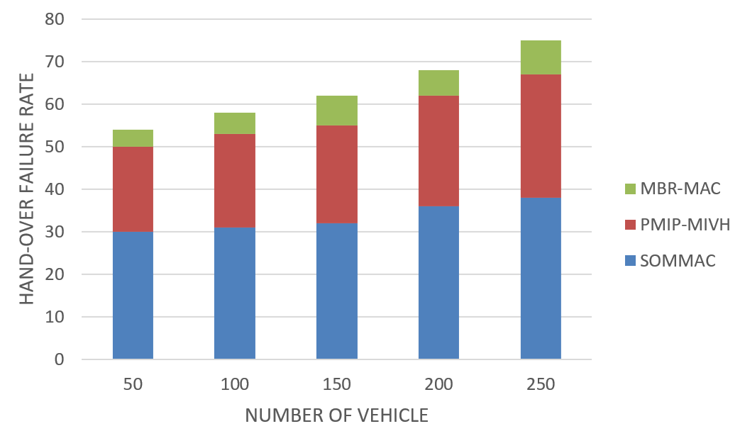
- Handover Failure Rate Vs. Number of Vehicles

Packet Delivery Rate
Whenever the number of nodes is increasing the connectivity among the peer is also increasing. The success of the packet delivery is depending on the connectivity between the RSCU and the vehicle. The system implements the soft handover technique which can reduce the link breakage. The proposed system utilizes the bridge reservation scheme which provides better channel assignment. The reliable connectivity ensures a better packet transmission rate with reduced network cost. The proposed MBR-MAC is improved over the existing approach SOMMAC with 20.4 % and PMIP-MIVH 12.4 %. The packet delivery success rate is represented in Fig. 6.
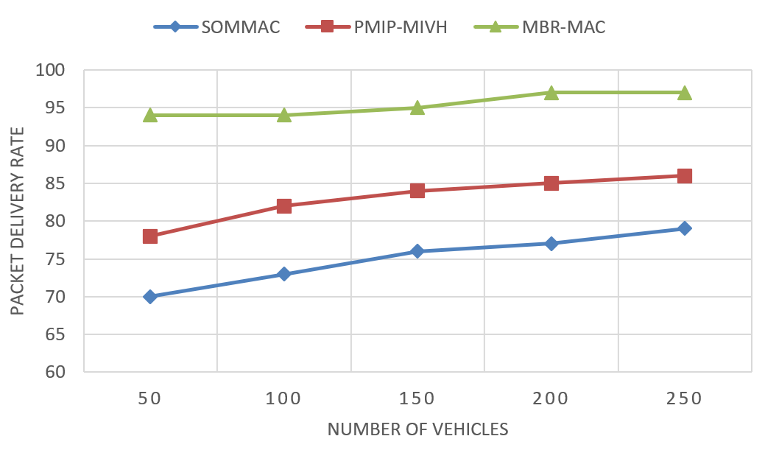
- PDR vs Number of Vehicles

CONCLUSION
The cyber-physical autonomous systems are suffered from the multi-channel assignment problem during the handover. Whenever a maximum count of vehicles is requesting for the handover, the RSUs must manage the service and the control relay channel access rights. During the multi-channel access, the RSUs may suffer from hidden and exposed node terminal problems. To solve such a problem, the time and frequency-based reservation scheme during the handover are introduced. The reservation scheme will greatly minimize connectivity failure during multi-vehicle channel access. An improved reservation scheme will predict and allot the available slots well in advance before the handover process. The proposed multi-hop bridge reservation approach provided an optimal solution with less link disconnection, packet failure rate, and improved throughput.

References

- Mirza Muntasir Nishat, Fahim Faisal, Rezwanur Rahman Dip, Sarker Md. Nasrullah, Ragib Ahsan, Fahim Shikder, Md. Asfi-Ar-Raihan Asif and Md. Ashraful Hoque,”A Comprehensive Analysis on Detecting Chronic Kidney Disease by Employing Machine Learning Algorithms”, Department of Electrical and Electronic Engineering, Islamic University of Technology (IUT), Dhaka, Bangladesh.10.4108/eai.13-8-2021.170671

